**Innovative outdoor learning and activities for**

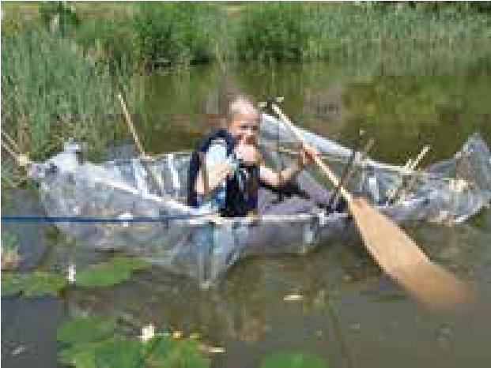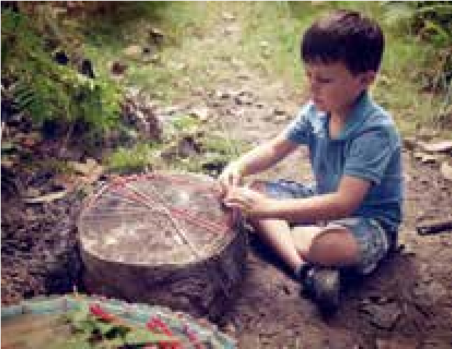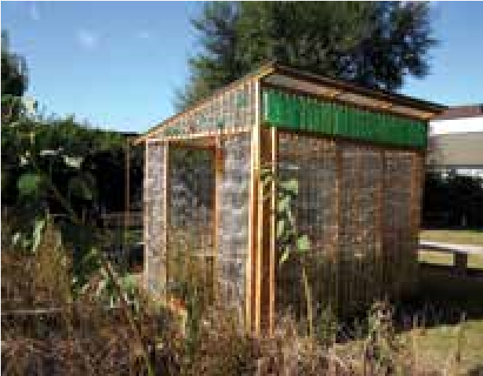

**www.sosussex.co.uk**



**schools, children and parents.**

***So Sussex are the creators of the award winning Elderflower Fields Festival***

**SCHOOLS WITHOUT WALLS**

**This popular program allows pupils in key stages 1 , 2 and 3 to undertake outdoor learning, within walking distance from the school or in their school grounds linked to their learning journeys and with the aim of creating broader bonds with the local community. We have developed modules that over the last few years we have shown to work across numerous learning journeys followed by schools.**

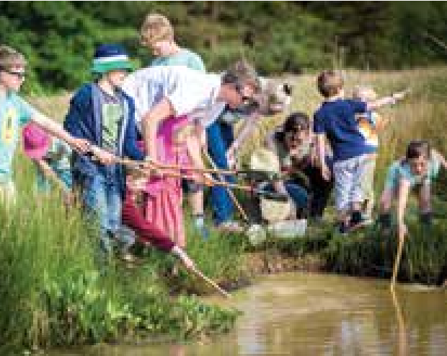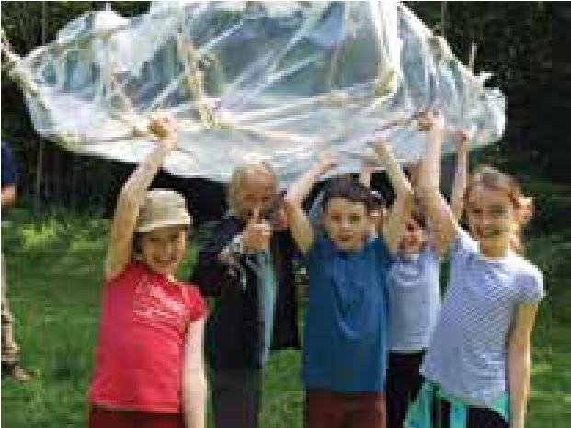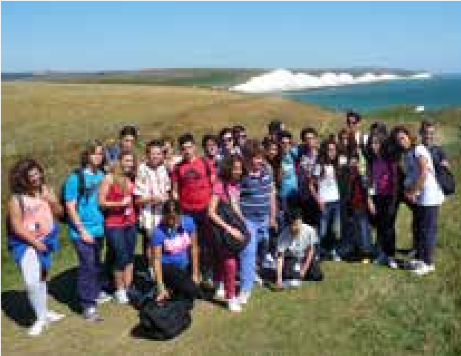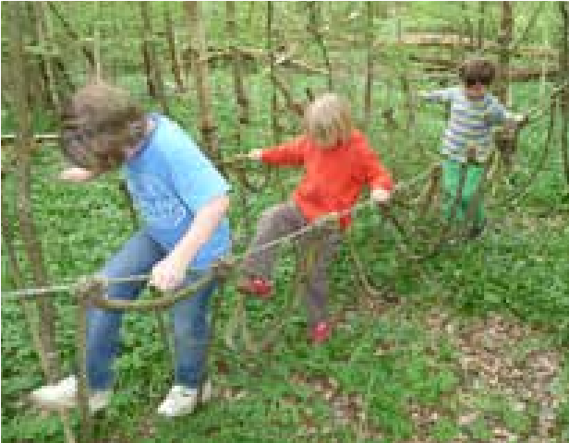

For enquiries and bookings please contact

**schoolswithoutwalls@sosussex.co.uk**

**Modules include:**

*Lakes & Rivers, Ancient Cultures, Art*

*in the Outdoors, Bugs & Beasties, Wild & Farmed Food,*

*Life in the Trees, Wild Games, Fire & Forage, Hills &*

*Valleys, People & Places, Energy & Recycling.*

*Residential Programmes and Holiday clubs -*

*Contact us for detail.*

**Developing Outdoor Spaces in Schools:** *– working with each year group we support schools to develop and improve*

*their outdoor spaces, projects have included; Recycled Bottle Greenhouse; Geodesic Domes & Willow pods*

**Activity Days;** *for Key Stage 2, 3 & 4 pupils we offer a range of Activity Days; Including Mountain Biking, Guided Hikes, Bushcraft Sessions, Team Challenges and Environmental Art sessions.*